

Contact: Alexa Tehansky

[ATehansky@aacn.nche.edu](mailto:ATehansky@aacn.nche.edu)

(202) 463-6930, extension 265

**Spokesperson Bio: Dr. Vernell DeWitty, PhD, RN**

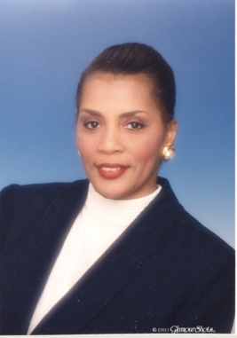Dr. DeWitty is currently the Program Deputy Director for Robert Wood Johnson New Careers in Nursing Scholarship Program, a national program of the American Association of Colleges of Nursing, funded by the Robert Wood Johnson Foundation. Dr. DeWitty has an extensive background in nursing and health care administration and program development. She served in various administrative capacities in university teaching hospitals as well as community based hospitals; she is a nurse educator, served as guest lecturer for the George Washington University School of Medicine and School of Public Health and currently is adjunct faculty for the George Mason University, College of Health and Human Services.

Dr. DeWitty earned her Doctoral degree from George Mason University, her Master’s in Business Administration degree from Howard University where she was selected as a member of the Beta Gamma Sigma Business Honor Society. While attending The Catholic University of America, where she earned the Master’s Degree in Nursing, she was selected as a member of Sigma Theta Tau National Nursing Honor Society. Vernell is also a fellow in the American College of Healthcare Executives.

As a Commonwealth Fellow she participated in expanded training in New Programs and Product Development at the Wharton School of Business and the Nurse Executive Training Program. She developed and implemented new health care products and programs, including the workforce advocacy programs for the Center, Consulting Practice for the Association of Women’s Health, Obstetric and Neonatal Nursing, The Women’s Heart Center at the George Washington University Hospital, and Kids, Infants and Parents Program at the Hospital for Sick Children.

**For more information visit our Web site:** [**http://www.newcareersinnursing.org/index.html**](http://www.newcareersinnursing.org/index.html)**.**

**Or contact Alexa Tehansky,** [**ATehansky@aacn.nche.edu**](mailto:ATehansky@aacn.nche.edu)**,**

**(202) 463-6930, extension 265.**