The Robert Wood Johnson Foundation New Careers in Nursing Program

Who We Are
The Robert Wood Johnson Foundation (RWJF) joined with the American Association of Colleges of Nursing (AACN) in 2008 to create New Careers in Nursing (NCIN), a scholarship program to help alleviate the nursing shortage and increase the diversity of nursing professionals. Through grants to schools of nursing, the program provides scholarships to college graduates with degrees in other fields who are enrolled in accelerated baccalaureate and master's nursing programs. These fast-track programs allow talented individuals from other disciplines to enter the nursing profession more quickly than through traditional programs.

What We Do
Launched as a three-year initiative, NCIN provides annual funds to support scholarships of $10,000 each to selected schools of nursing. A school may apply for between five and 30 scholarships per year to be awarded to students from underrepresented groups in nursing or disadvantaged backgrounds. Through NCIN, more than 1,500 college graduates without nursing degrees will be enrolled in accelerated baccalaureate and master's nursing programs designed to:
- Help alleviate the nursing shortage
- Increase the diversity of nursing professionals
- Expand capacity in baccalaureate and graduate nursing programs
- Enhance the pipeline of potential nurse faculty

NCIN and the State of the Nursing Workforce
The most efficient way to prepare new nurses at an advanced level is through accelerated baccalaureate and master's programs in nursing. These intense programs target students who have baccalaureate degrees in other disciplines and wish to transition into nursing. Students receive the same number of clinical hours as their counterparts in traditional nursing programs and accomplish programmatic objectives in an average of 12 to 18 months versus 24 months.

Expanding capacity in all types of baccalaureate nursing programs is crucial to addressing the nursing shortage. Nursing schools nationwide are working to admit all qualified applicants, yet a shortage of faculty is constraining scholars’ ability to meet the demand. Research shows that nurses prepared in baccalaureate programs are four times more likely than other nurses to pursue graduate degrees in nursing, the required credentials to teach. NCIN is doing its part to expand the population of potential future faculty by focusing on preparing more baccalaureate nurses.
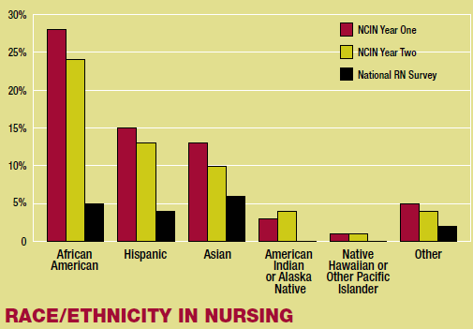
NCIN is Changing the Face of Nursing
To ensure quality care, the nation also requires a nursing workforce that reflects the country’s population. Nurse leaders have recognized a strong connection between having a diverse nursing workforce and the ability to provide culturally-competent services.

NCIN is helping diversify the student population and bring more underrepresented groups into nursing. A recent survey of second-year scholarship recipients found that 58% of NCIN students are racially and ethnically diverse, including students from African American (25%), Hispanic (13%), and Asian (11%) origin. Thirty seven percent (37%) of NCIN scholars are male. The diversity of NCIN scholars is further emphasized when compared to national data:

A 2008 U.S. Department on Health and Human Services survey found that the national nursing population is 83.2% Caucasian (non-Hispanic) and 6.6% male.

A 2009 – 2010 AACN report found that only 24.7% of undergraduate nursing students represent minority populations while 75.3% are Caucasian. Male students account for only 10.8% of the undergraduate nursing population.

The NCIN program is also helping to broaden the skills base within the overall nursing workforce. A 2004 survey reported that a majority (52%) of working nurses had previous experience in a health-related occupation before pursuing nursing education. While most NCIN scholarship recipients are moving into nursing with degrees in the physical or behavioral sciences (48%), a sizable number are entering with degrees in business, liberal arts and health sciences.

The survey data also show that the NCIN program is succeeding in removing financial barriers to nursing careers. Second-year scholarship recipients cite the NCIN scholarship as a major funding source for their education, with most relying on educational loans (90.6%), personal savings (35.1%), and family support (22.0%) to finance the remainder of their expenses. Since most students are not working while enrolled in a program (66.6%), many students indicate that this career transition would not be possible without the NCIN funding.

Finally, the RWJF New Careers in Nursing Scholarship Program is clearly having a positive impact on our nation’s nursing schools. Many programs that receive awards have used the NCIN funding to help leverage resources to add new faculty, secure matching funding from state programs, develop mentoring and leadership development programs, strengthen outreach efforts, and establish new partnerships with community and practice leaders. These efforts will enable schools to sustain their program expansion while positioning them for future growth.

Health Care Reform and NCIN
The Patient Protection and Affordable Care Act encompasses several nursing provisions that align with the goals of NCIN; however, many of the funded programs are temporary and must be evaluated for appropriations each year. The new law does seek to expand access to diversity workforce grants for diploma and associate degree nurses – a different target population from NCIN students with baccalaureate degrees. NCIN will continue to be a vital source of funding for students traditionally underrepresented in nursing who are not eligible for grants under the new health reform law.

NCIN Looking Ahead
In this third year of awards, NCIN will provide scholarships to 511 students entering accelerated nursing programs during the 2010-2011 academic year. To date, the NCIN program has supported 1,917 students at 101 schools of nursing - an investment of just over $19 million in nursing education. NCIN is making an impact nationwide by awarding scholarships to 100 schools in 38 states and the District of Columbia. This year, the NCIN program celebrated the graduation of 212 students who can now follow their dream of becoming a nurse. NCIN will continue to move forward with a stronger emphasis on scholar recruitment and providing a community for students as they move beyond their accelerated degrees and into the profession.

